Coach’s Guide – Using Your Team Page to access roster, schedule, send emails
- Each team has a ‘Team Page’ on the website. There are two different ways you can get to your team’s page:
  - On the main www.cbsl.org website – go to the ‘Team Central’ tab and select the ‘Team Directory’ page. All the teams are listed there, and you can choose the ‘Team Home’ link under the name of your team. (you need to be logged in for this to work correctly)
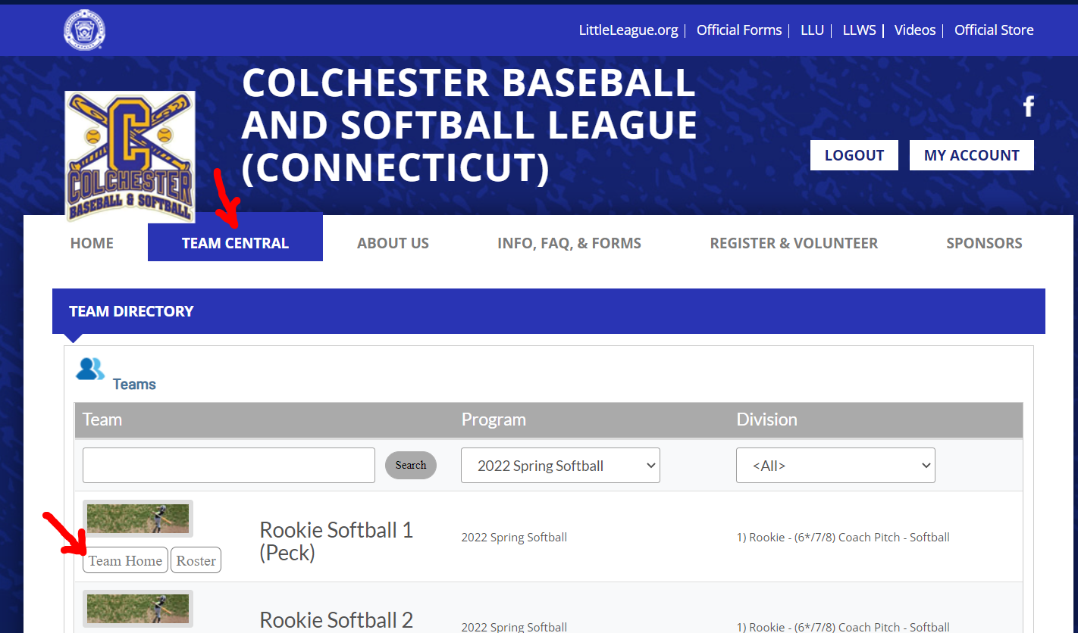

  - If you are in your Account (and logged in), you can go to the ‘Volunteer’ page in the left hand menu and then for any of your Head Coach positions, you can choose the ‘Visit Team Page’ link below that line.
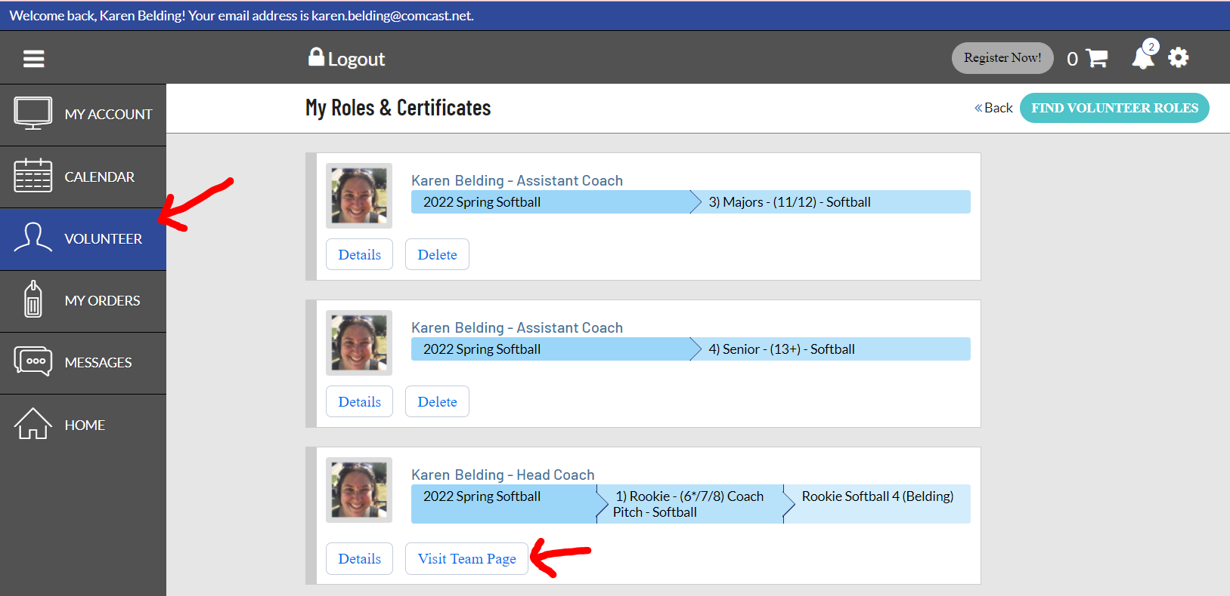

- On your team’s page, since you are a head coach, you will have typical options like being able to view the roster, being able to view the calendar, etc, but you will also be able to use the ‘Email’ option to message everyone on your team directly from the website.
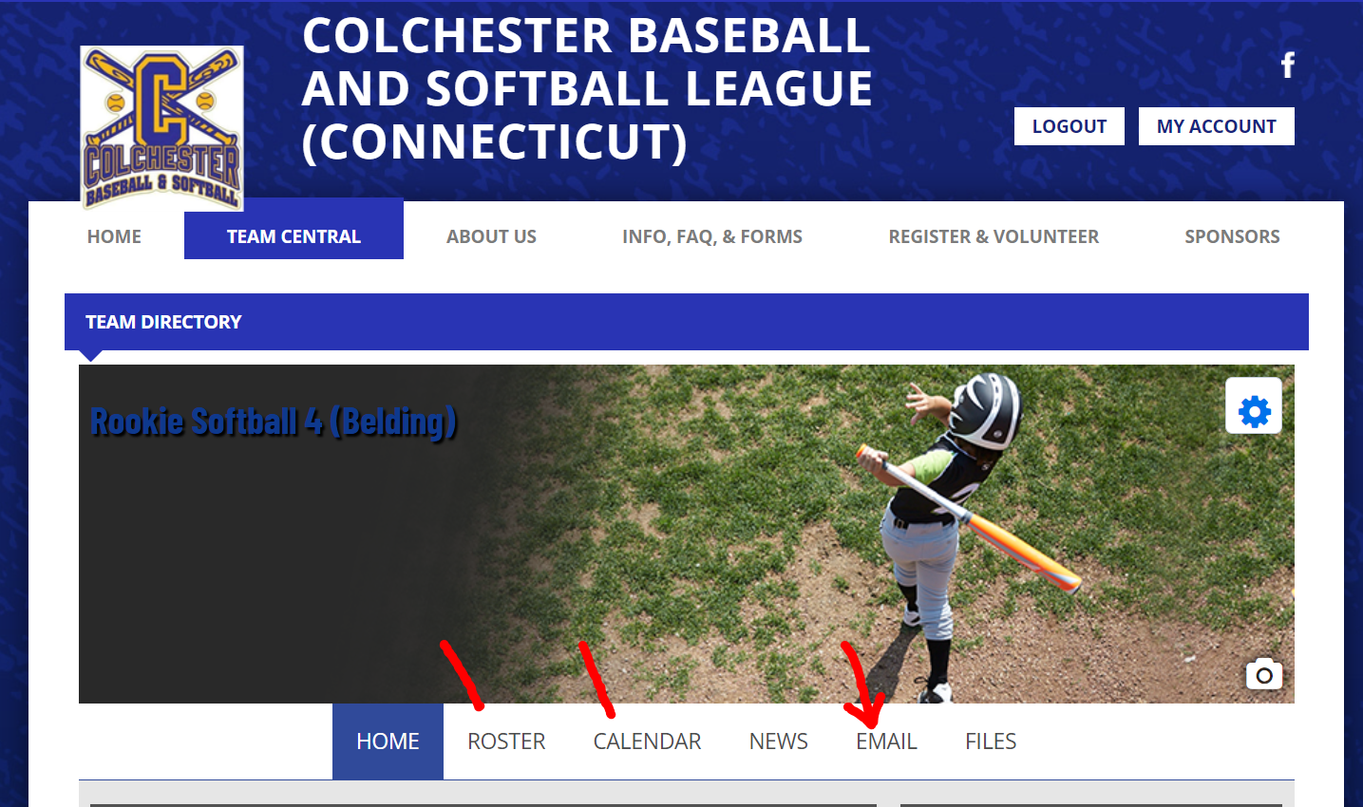

- You can opt to send to ‘Everyone’ by checking that box or you can select individuals or specific set of volunteers or players to email. Type in the message you want to send into the message box (just like you would type any email you send, including your name, etc) and then attach any files or attachments. The scroll down to check boxes for who in the volunteers or players you want to get this message – note the ‘Send to all’ checkbox at the top that is the fastest way to choose everyone.
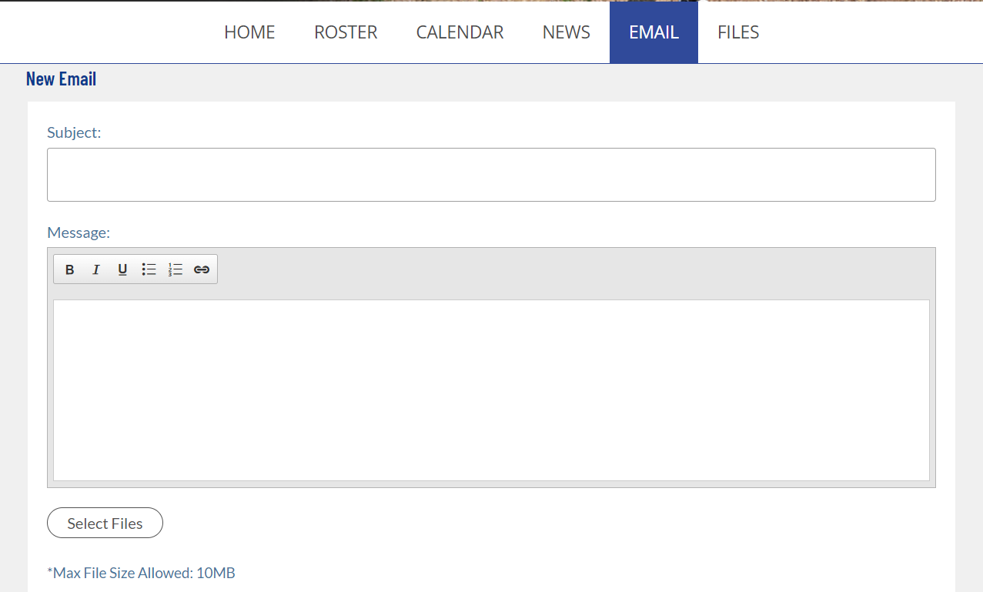
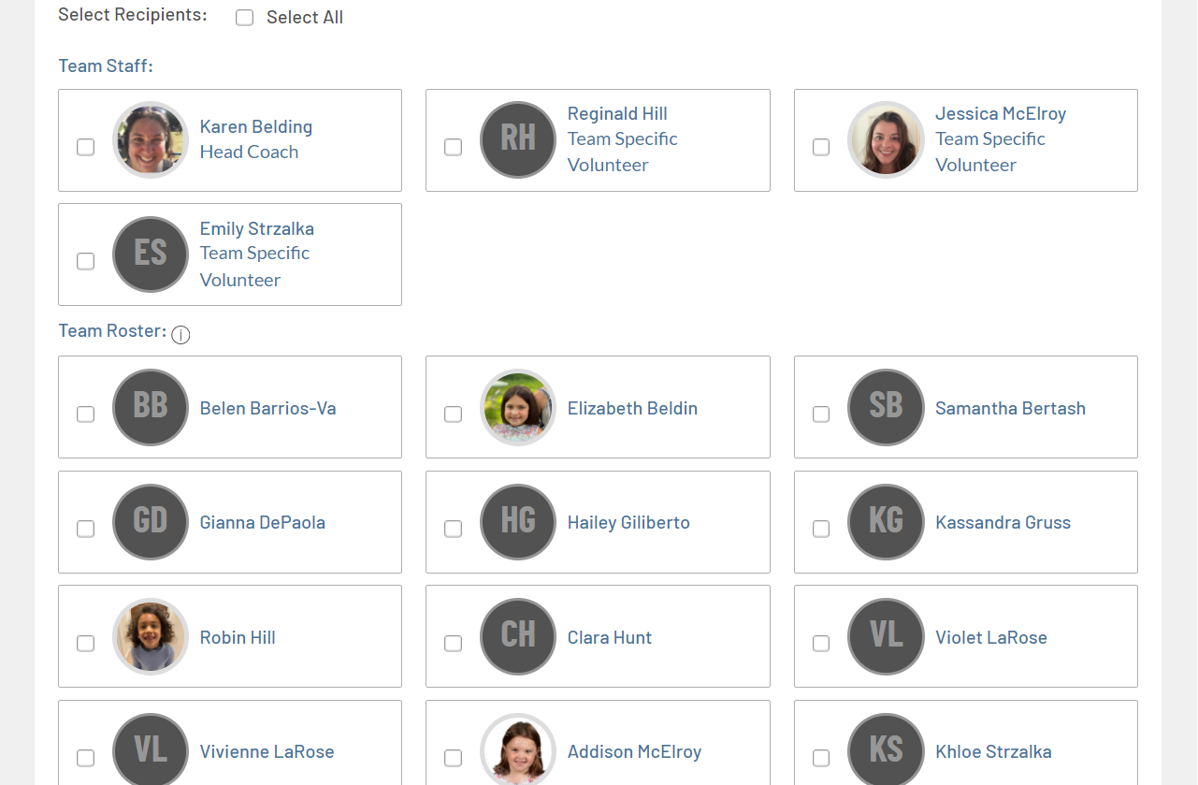

- If parents or others related to the players want additional email addresses to receive the emails, they need to log into their account and add the additional addresses there.
  - Go to www.cbsl.org and use the ‘Login’ button. Then click on the ‘My Account’ button.
  - Click on the icon to the upper right for ‘Account Holder Settings’ – looks like a cog
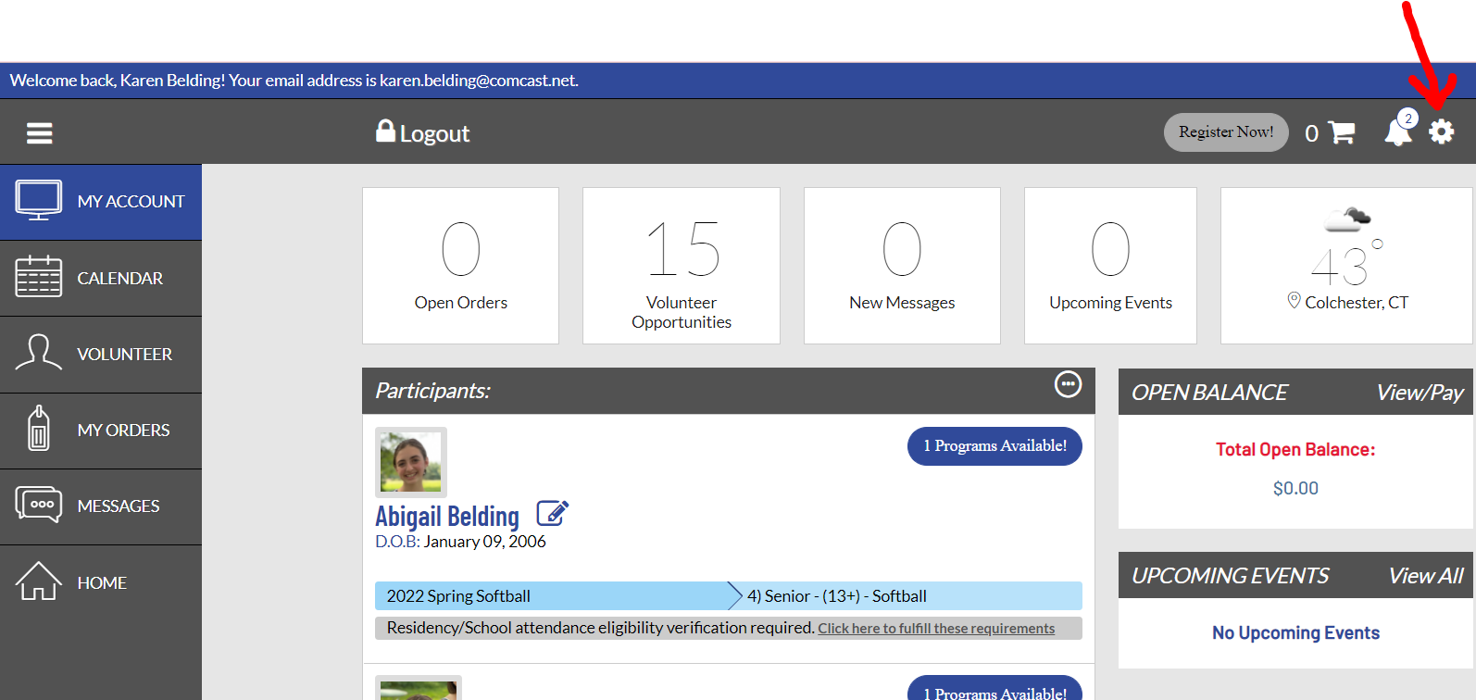

  - Once in the ‘Account Holder Settings’ page, they can change their own email address in the ‘Contact Information’ area. If they need to add another person’s email address, they can use the ‘Add Additional Account Holder’ clickable link towards the bottom to add an additional parent or person along with their email address – then that person/email will also receive communications and be able to access the team page, etc. Lastly – they can also change their password for the website on this screen.
  - Be sure to click the ‘Save’ button at the bottom once changes are made.
